Nama : Abdi Akhsanul Afkar

NIM : 18090048

Kelas : 5C

PRAKTEK W5

1. Code

Autoload.php-application / config.php

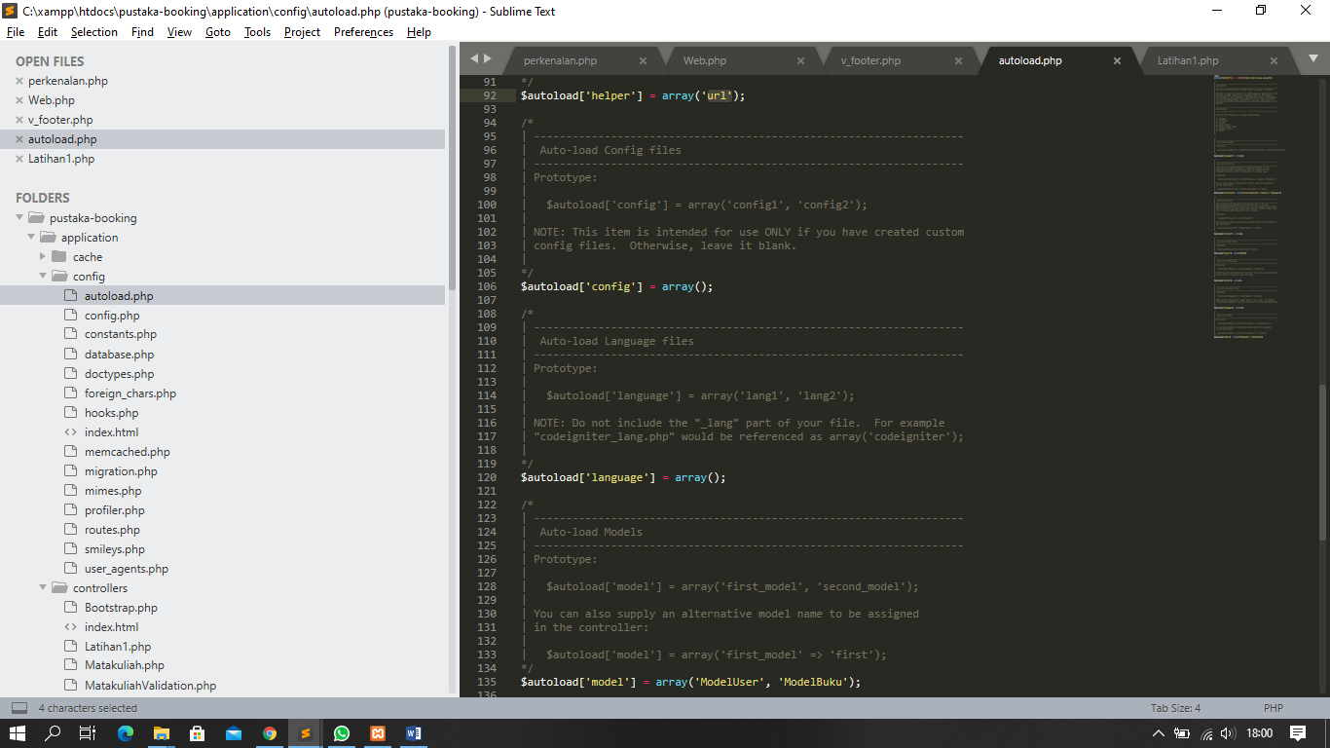

MatakuliahValidation.php - application / controller

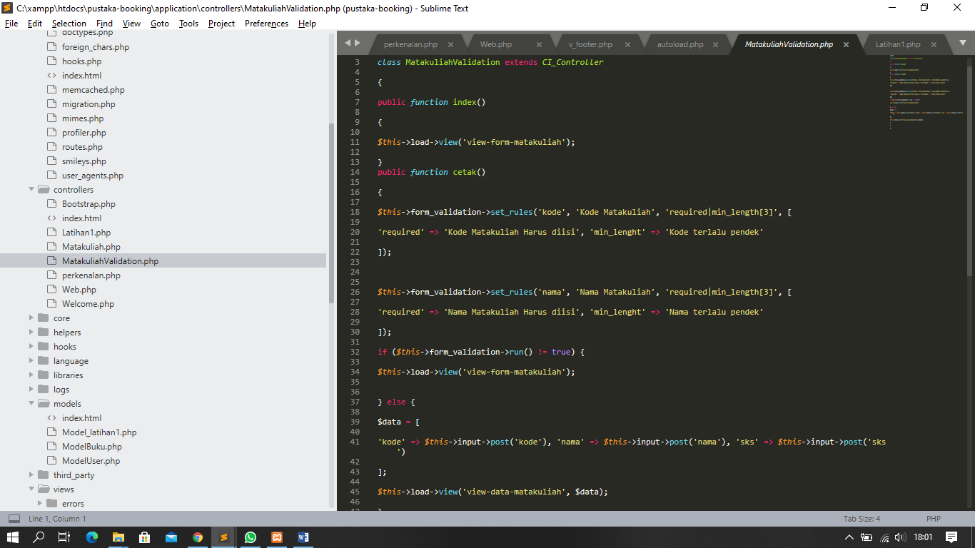

form-matakuliah.php => application / views

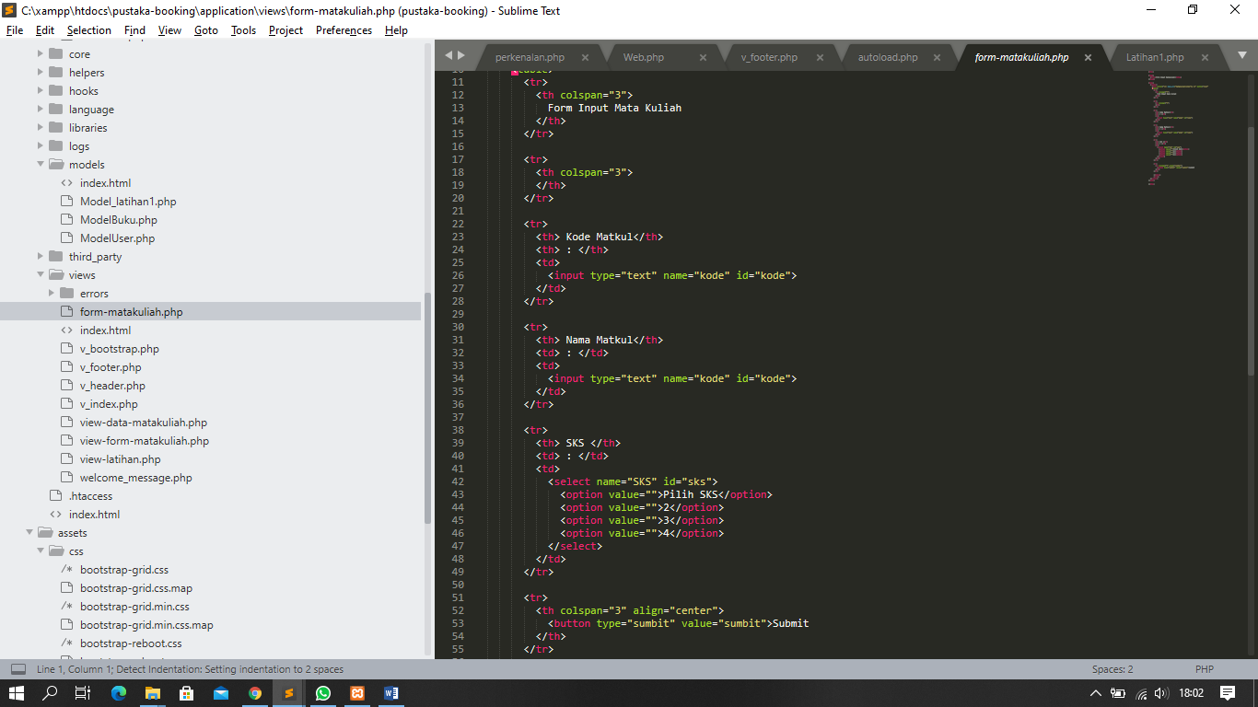

1. URL

<http://localhost/pustaka-booking/MatakuliahValidation>

1. Capture Hasil

